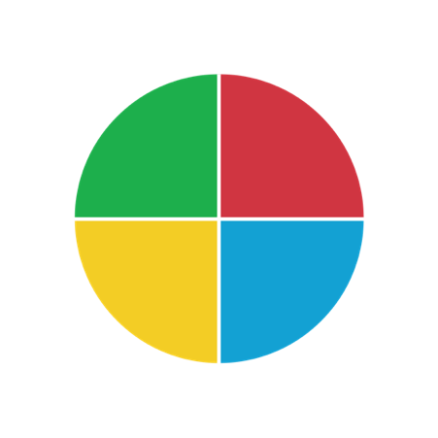
A Guide to Me

Please call me (name, pronunciation):

I use these pronouns:

What I do here (job title or role, project, responsibilities):

My workplace priorities (pulled from your
profile or customized):

The best way to communicate with me
(e.g., chat, email, phone; preferred hours):

If scheduling a meeting with me, please
(hours available, logistics, pre- or post-meeting communication preferences):

I am motivated by (from profile or customized):

What I value in teammates/colleagues:

My DiSC style
(plus additional
priorities):

I do my best work when (consider environment, request type, work type):

When stressed I might (from profile or customized):

I might not do my best if (pet peeves, frustrations):

How you can support my work (how to give feedback, acknowledge my contributions, etc.):

Other interesting tidbits about me:

